**Software engineering project**

**Health app documentation**

**DATE: 6/19/2023**

**Development team**

**Name**: Victor Ukaigwe Chinedu

**Mat no**: vug\csc\21\5173

**Name**: Akpusi Favour

**Mat no**: vug\csc\21\5192

**Name**: David Okafor

**Mat no**: vug\csc\21\5191

**Table of Contents**

**I. Requirement documentation**

-Brief overview of documentation

-overview.

-Functional

-Assumptions and constraints related to functionality

- functional requirements

**II. Software Design documentation:**

-Data flow diagram

-process flow chart

**III. Technical documentation**

-tools used in development

-tools used in styling/design

**IV. User documentation:**

-Purpose

-Scope

-Target audience

-System requirements

-Installation steps

-Features

**I. Requirement documentation**

**Brief overview of the documentation**

* Purpose of the requirement documentation: the purpose of this is understand user needs, and defines the scope of the software project by specifying what will and will not be included.
* This documentation covers the requirement, functional requirement, and non functional for the Health App. It does not include detailed technical specifications or development-related information.

**System Overview:**

* health app can be accessed online through our site provides options for logging in, for people who may have already created an account with us an sign in for those who want to join our health app and make their lives better.
* The app provides minimal functionality and is able to perform minor tasks such a preparing a meal plan for the user and helping with setting goals for workout plans.
* It is available for use on browsers for now and will soon be able to be accessed on app stores

**Functional Requirements:**

* User Registration: The app should provide a user registration feature that allows users to create an account by entering their name, email address, and password. The registration process should include basic validation to ensure the entered information is valid.
* User Login: The app should have a user login feature that allows registered users to securely log into their accounts using their email address and password.
* BMI Calculation: The app should include a BMI calculation feature that enables users to input their height and weight. Upon submission, the app should calculate the user's BMI and display the result along with a corresponding weight category (e.g., underweight, normal weight, overweight, obese).
* Weight Tracking: The app should allow users to track their weight over time. Users should be able to enter their weight measurements and view a visual representation of their weight history, such as a line graph or chart.
* Meal Logging: The app should provide a feature for users to log their meals. Users should be able to add food items, specify portion sizes, and record the date and time of each meal. The app should also calculate and display the total calorie intake for each logged meal.
* Nutritional Information: The app should provide access to a nutritional database that contains information about various food items. Users should be able to search for specific foods and view their nutritional details, such as calories, macronutrients (carbohydrates, proteins, fats), and vitamins.
* Daily Calorie Goal: The app should allow users to set a daily calorie goal based on their health and fitness objectives. The app should provide recommendations or guidelines for calorie goals based on factors like age, gender, weight, and activity level.
* Meal Suggestions: The app should provide users with meal suggestions based on their dietary preferences, calorie goals, and nutritional requirements. The suggestions can include recipe ideas or pre-planned meals that meet the user's criteria.
* Health Tips and Articles: The app should offer a section with health tips and articles related to nutrition, fitness, and general well-being. Users should be able to browse and read informative content to gain knowledge and make informed decisions about their health.
* Profile Management: The app should allow users to manage their profiles by providing options to edit personal information, update goals, and adjust settings related to notifications and preferences.
* Integration with Fitness Trackers: The app should have the capability to integrate with popular fitness trackers or wearable devices. This integration would allow users to sync their activity data, such as step count or workout information, with the app for a more comprehensive health tracking experience.

**Assumptions and constraints related to functionality**

* Database: The app does not have a database for storing user information so user information might be lost at some point in time and user would have to restart their progress. Although in subsequent editions would include implementing secure data storage, encrypted communication, and adherence to relevant data protection regulations.
* Water Intake Tracking: The app does not include a feature for users to track their daily water intake. In version to users should be able to enter the amount of water they consume throughout the day, and the app should display the total intake and provide reminders to stay hydrated.
* Reminders and Notifications: The app does not have a reminder feature that sends notifications to users to remind them to log their meals, track their weight, or engage in healthy habits.

**Non-Functional Requirements:**

* Performance: The app should have fast response times and minimal latency to ensure a smooth user experience.
* Reliability: The app should be reliable and available for use without frequent crashes or downtime.
* Usability: The app should have an intuitive and user-friendly interface, making it easy for users to navigate and perform basic operations.
* Compatibility: The app should be compatible with a wide range of devices and operating systems, ensuring accessibility to a broad user base.
* Accessibility: The app should be designed to be accessible to users with disabilities, adhering to accessibility standards and guidelines.
* Localization: The app should support multiple languages and provide localization options to cater to users from different regions.

**II. Software Design Documentation**

Data flow diagram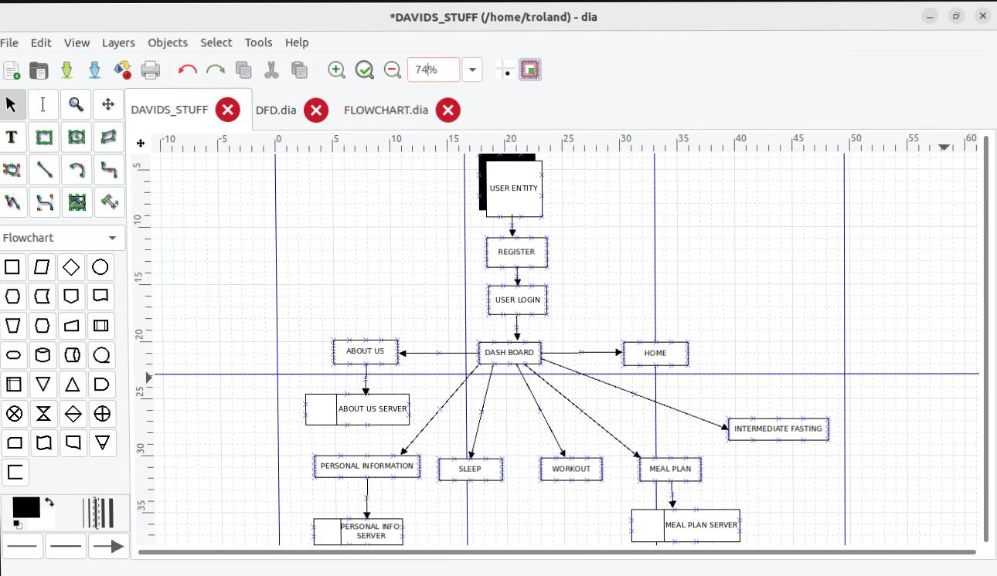

Process flow chart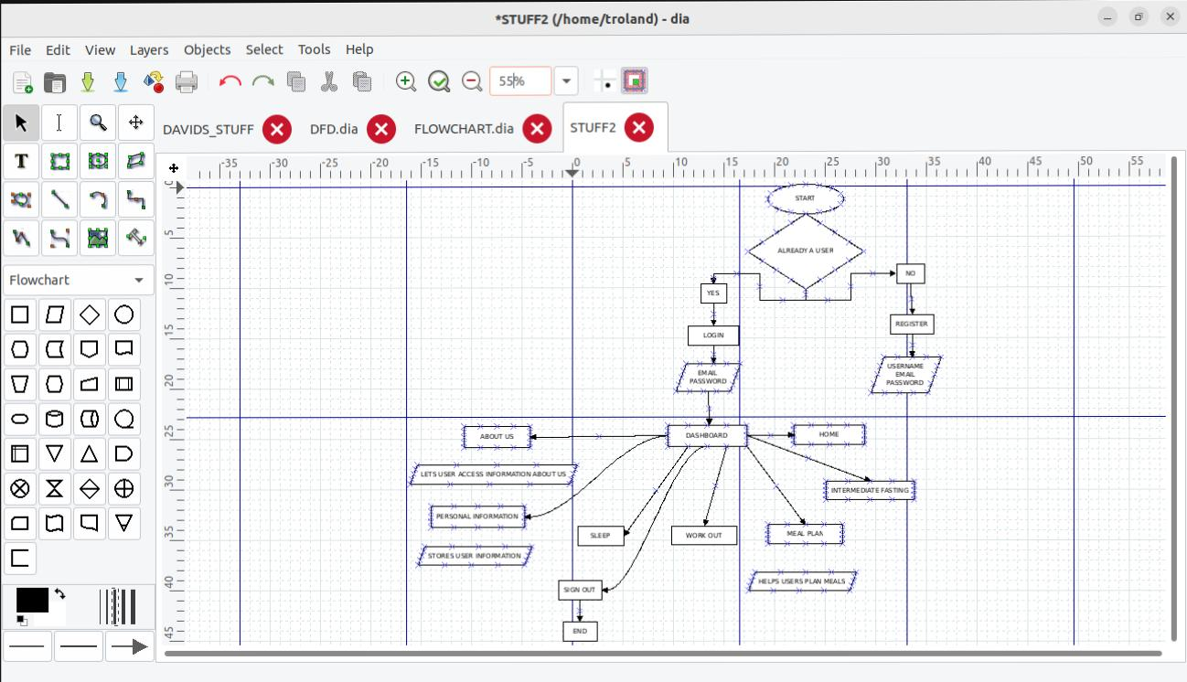

**III. Technical Documentation**

This documentation covers the tools used in development of the health, as well as styling and/or design for the Health App. It does not include detailed technical specifications or specify development-related processes.

Tools used in development

Tools used in styling/design

**IV. User Documentation**

**Purpose**

The Health App is designed to help users plan their meals, calculate their BMI (Body Mass Index), and provide advice on living a healthier life. It aims to assist users in making informed decisions about their nutrition and lifestyle.

**Scope**

This documentation covers the installation, setup, and usage instructions for the Health App. It does not include detailed technical specifications or development-related information.

**Target Audience**

This documentation is intended for end-users of the Health App. It assumes basic knowledge of using mobile applications and provides step-by-step instructions to help users navigate and utilize the app’s functionalities

**System Requirements**

To use the Health App, ensure that your device meets the following requirements:

Operating System: Android 7.0 or later, iOS 11.0 or later.

Internet Connection: Required for accessing app features and content.

Storage Space: at least 2 gig.

**Installation Steps**

Follow these steps to install the Health App on your device:

1. Open the App Store (iOS) or Play Store (Android) on your device.

2. Search for “Health App” in the store’s search bar.

3. Locate the Health App from the search results.

4. Tap on the app to view its details.

5. Tap the “Install” button to begin the installation process.

6. Wait for the app to download and install on your device.

7. Once installed, locate the app icon on your home screen or app drawer.

**The Health App provides the following key features:**

**Meal Planning**

* The Meal Planning feature allows users to create personalized meal plans based on their dietary preferences and goals. Users can select from a variety of recipes, create shopping lists, and track their daily calorie intake.

**BMI Calculation**

* The BMI Calculation feature enables users to calculate their Body Mass Index, a measure of body fat based on height and weight. By inputting their height and weight, users can obtain their BMI value and understand their weight status.

**Health Advice**

* The Health Advice feature provides users with valuable tips and recommendations on how to lead a healthier lifestyle. It covers topics such as nutrition, exercise, stress management, and sleep hygiene, helping users make informed choices to improve their overall well-being.

**User Guide**

Creating an Account

1. Launch the Health App on your device.
2. Tap on the “Sign Up” or “Create Account” button.
3. Enter the required information, such as your name, email address, and password.
4. Agree to the terms and conditions, if prompted.
5. Tap on the “Create Account” button to complete the registration